AFYA BORA CONSORTIUM GLOBAL HEALTH LEADERSHIP FELLOWSHIP PROGRAM
PROJECT MANAGEMENT MODULE

Participant and Instructor Guide
Instructors:
Susan Chapman and Kenneth Ngure

AFYA BORA CONSORTIUM
PROJECT MANAGEMENT MODULE

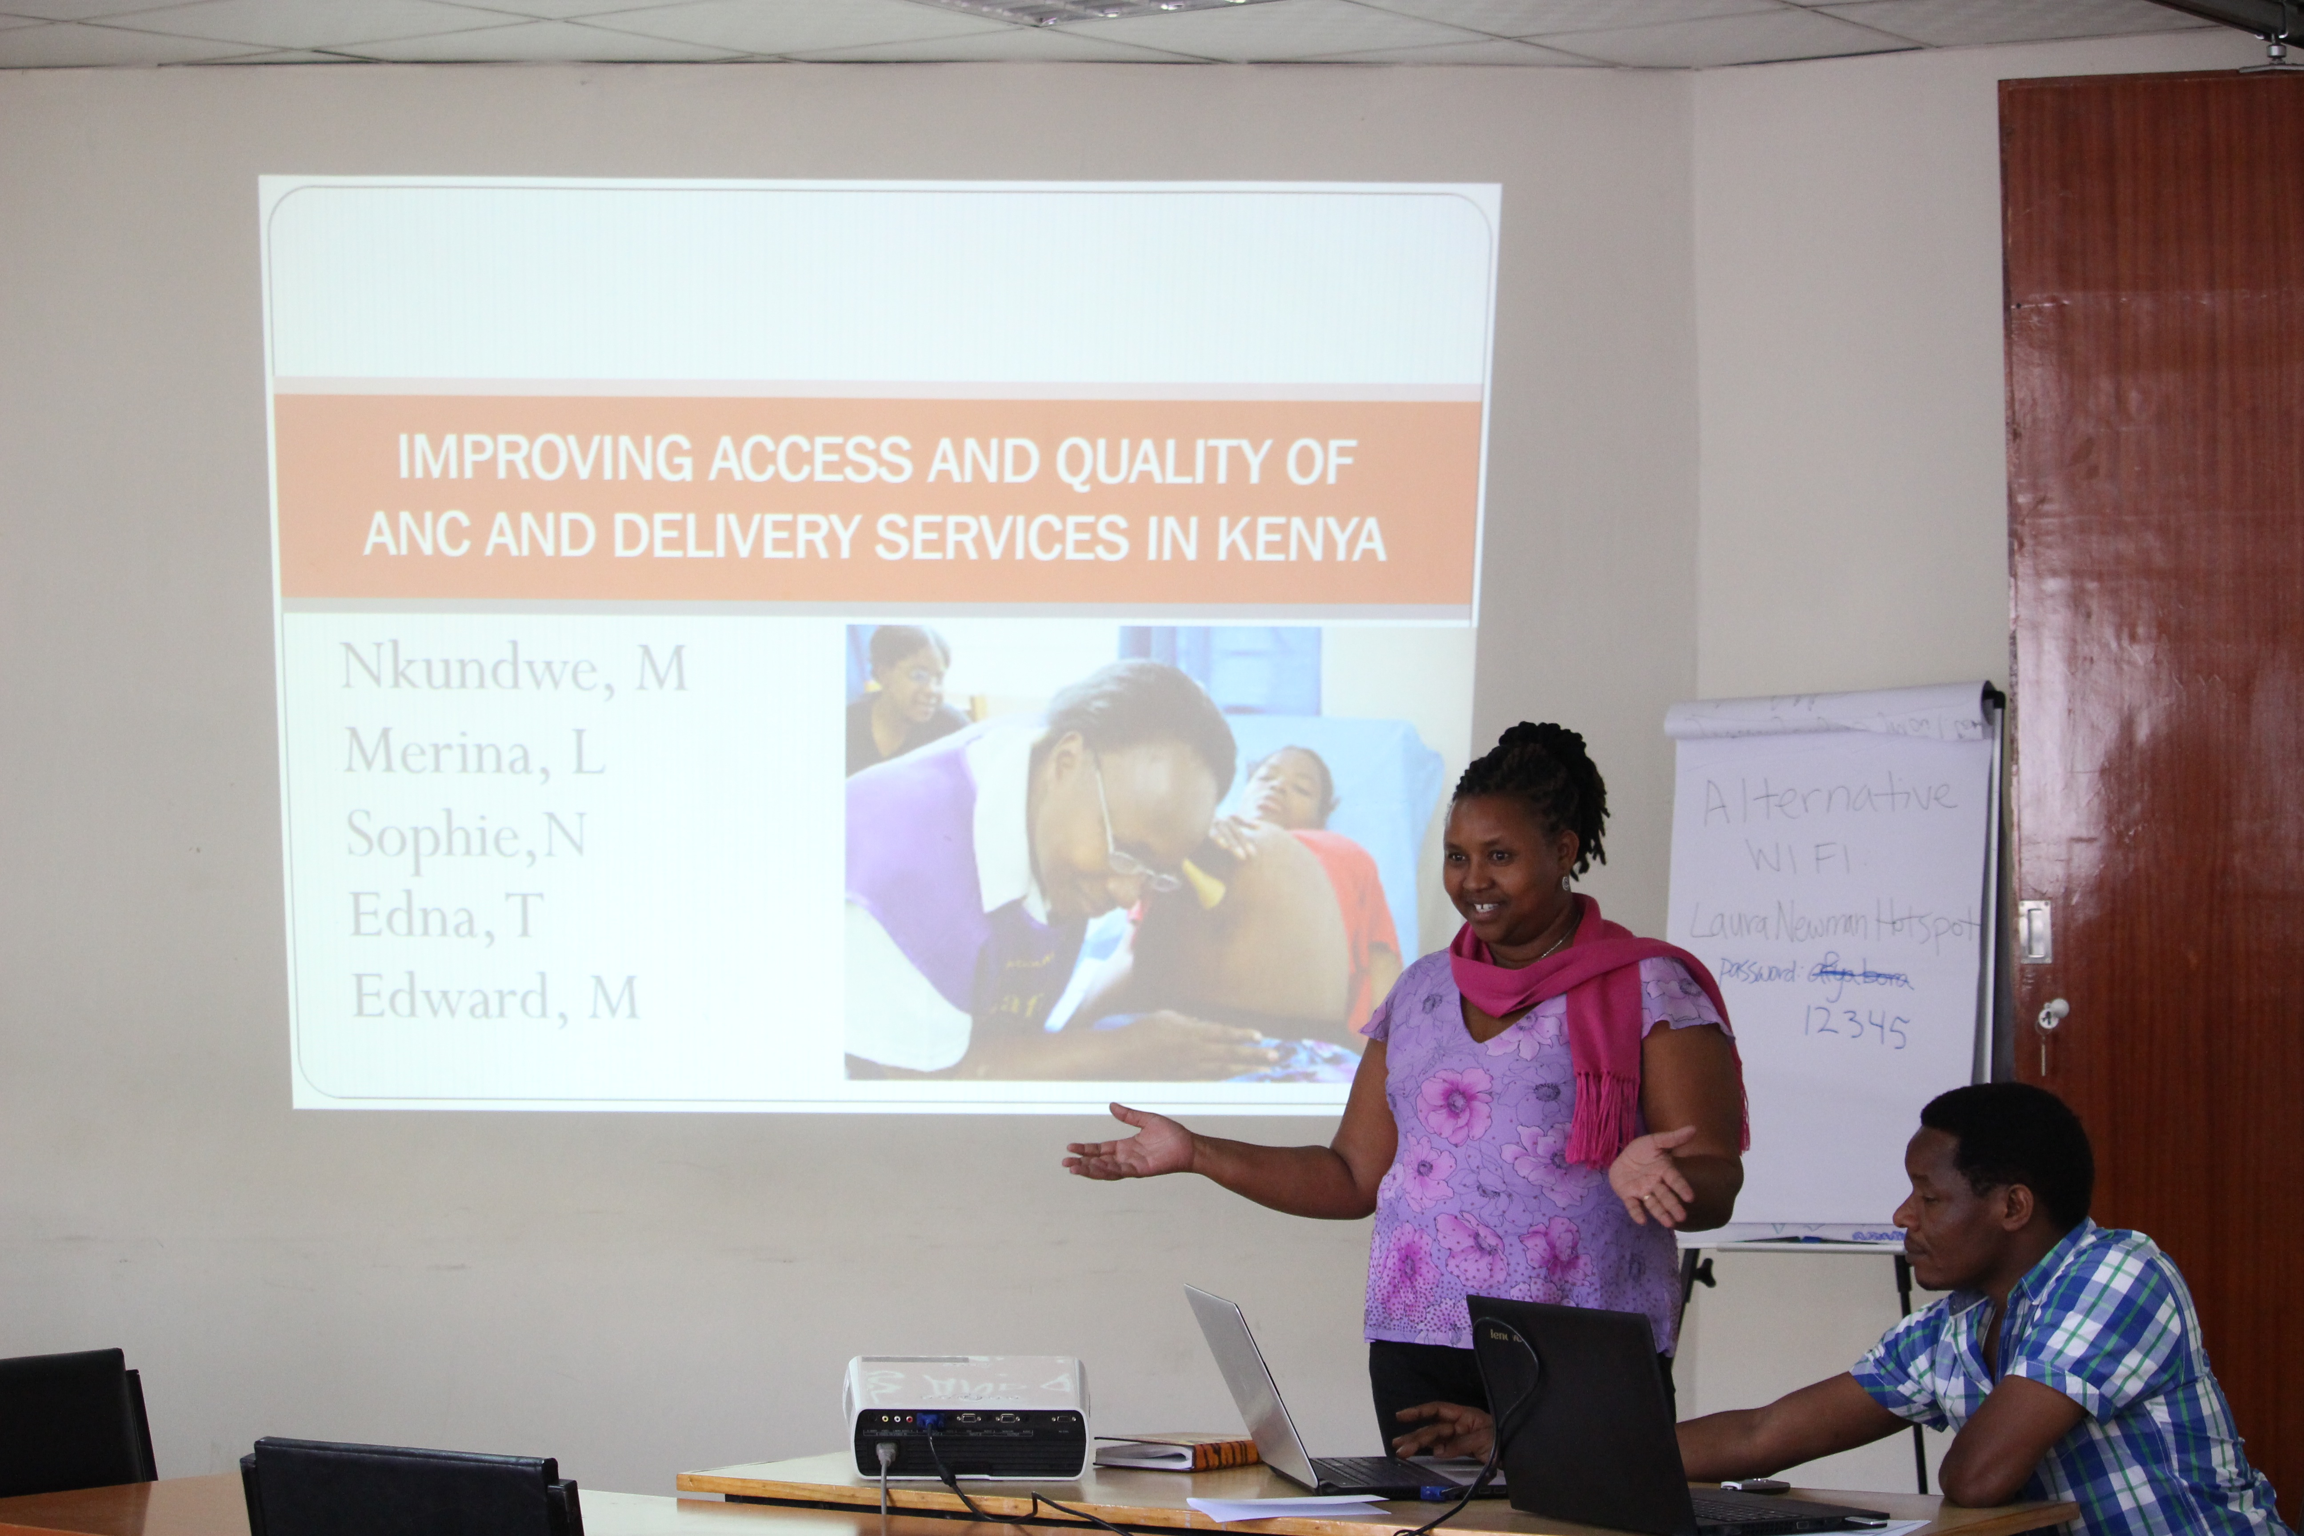

Guide for Fellows and Instructors

Contact Us:

Susan Chapman, PhD, RN  Professor | Department of Social & Behavioral Sciences  School of Nursing  University of California, San Francisco  San Francisco, CA 94118  Email: susan.chapman@ucsf.edu
Kenneth Ngure MPH, MSc, PhD  Senior Lecturer | Department of Public and Community Health  School of Public Health  Jomo Kenyatta University of Agriculture and Technology  Nairobi, Kenya  Email: k_ngure@hotmail.com, kngure@jkuat.ac.ke

Table of Contents
Course Overview 4
Goals of the Module 4
Learning Objectives: 4
Teaching Methods: 5
Module Schedule 5
Project Management Reflection 6
Suggested Readings 7

Course Overview

A critical component of implementing a research study or project is Project Management. A Project Manager is responsible for a multitude of duties/tasks, including preparing and managing grants and project budgets, complying with government regulations, preparing project reports and regulatory submissions, creating data collection forms, managing project data, managing human resources, conducting regular project team meetings, preparing and managing the project timeline, and producing the project deliverables. Sometimes a project manager may need to focus on improving processes when administrative, clinical, or research problems occur. Many professionals who have taken on the role as project manager know all too well the difficulties of learning all these tasks “on-the job”. This module focuses on the skill set required for effective project management.

Goals of the Module

Project management is an essential skill for success in any organization. In today’s complex health care delivery and research environment a project-based team approach is becoming common and necessary. In order to implement successful projects in this environment, one must pay great attention to planning. This includes developing and managing timelines, budgets, scope of work, risks, unforeseen problems, clients, stakeholders, and fellow team members.

Effective project management ensures cost effective use of valuable resources such as people and funds.

The skill set required for effective project management is not necessarily the same set of skills needed for success as a clinician or researcher. Many clinical staff in health care have not been taught project management skills. Project management has too often been seen as an unnecessary add-on or something that just will happen automatically.

This workshop will assist you to develop the range of skills appropriate for effective project management in a health care or research setting.

Learning Objectives:

The objective of this module is to provide fellows with the foundational skills necessary to be successful in Project Management. At the end of the course fellows should be able to:

- Explain (Understand) what is meant by the meaning of “project” and provide examples of different types of projects.
- Describe the concepts used in project management, project planning and development of project plan, budgeting and financial management, human resources management, data management, development and monitoring of project timeline and deliverables, interim and final reporting, and internal evaluation.
- Participate in group discussions of issues in project management in field placements and problem solve with discussion group members.

Teaching Methods:

The course is taught in a distance learning format with 5 recorded lectures, 2 recommended discussion groups, and a reflection assignment. Weekly quizzes assess knowledge of concepts and application of project management tools. Quizzes are due every Tuesday.
The reflection assignment is due in Week 4. This assignment is required regardless of whether you participate in the final discussion group.
The final discussion group will be an opportunity to discuss the reflection and ask any questions you have about the lectures in this module.

Module Schedule

Week | Topic | Lecturer | Evaluation | Quiz/ Assignment Due Date | Conference Discussion Groups
1st Week  May 3, 2016 | The Project Life Cycle | Susan Chapman | Multiple Choice Questions | May 17, 2016
2nd Week  May 9, 2016 | Timelines, Deliverables, Metrics | Kenneth Ngure | Multiple Choice Questions | May 17, 2016 | May 20, 2016 at 8:00AM PDT with Susan Chapman  (Optional attendance)
3rd Week  May 16, 2016 | Budgeting, HR, Frameworks, and Sustainability | Samuel Runo | Multiple Choice Questions | May 24, 2016
4th Week  May 23, 2016 | Project Evaluation, Monitoring, and Compliance | Francis Njiri | Multiple Choice Questions | May 31, 2016  Project Management Reflection Due (see below)
5st Week  May 30, 2105 | Challenges and Barriers to project management | Kenneth Ngure &  Susan Chapman | Multiple Choice Questions | June 7, 2016 | June 8 or 9, 2016 at TBD time with Kenneth Ngure  (Optional attendance)

Project Management Reflection

The project life cycle outlines a framework in which to consider the progression of steps in project management. Consider your attachment site placement(s) over this year and identify one project in which you participated. You don’t necessarily have to have participated in the entire project. Complete the sections that are relevant to your participation. (1-2 pages)

Project Management Life Cycle | Reflect on how each of the steps occurred on the project you selected? | While considering the lecture on the project life cycle, what knowledge or skills would have made this step more effective? | What knowledge or skills from this framework will you use moving forward in your work in project management? Consider how you might apply them.
Project Initiation
Project Planning
Project Execution
Project Closure

Suggested Readings

Carroll-Barefield, A. & Smith, S.P., (2001). Case Study: Incorporating Project Management Skills in the Design of a Clinical Research Patient Management System, Health Care Manager, (1), 70–76.

De Wit, A. (1988). Measurement of project success. International journal of project management, 6(3), 164-170.

Dwyer, J., Stanton, P., & Thiessen, V. (2004). Project Management in Health and Community Services: Getting good ideas to work. Psychology Press.

Institute for Healthcare Improvement: PDSA Worksheet. Review website
http://www.ihi.org/knowledge/Pages/Tools/PlanDoStudyActWorksheet.aspx
NHS Institute for Innovation and Improvement, Quality and Service Improvement Tools, PDSA, 2008.

Klein, G. (2007). Performing a project premortem. Harvard Business Review,85(9), 18-19.

Munns, A. K., & Bjeirmi, B. F. (1996). The role of project management in achieving project success. International Journal of Project Management, 14(2), 81-87.

Payne JM, France KE, Henley N, D’Antoine HA, Bartu AE, Elliott EJ and Bower C, (2011). Researchers’ experience with project management in health and medical research: Results from a post-project review, BMC Public Health, 11:424.

